Blog

First steps and considerations

1. reference material

* I could just start sculpting around but since the target audience is in the field of academics, it makes more sense to attempt to recreate a real roman aqueduct, instead of just randomly create pillars and arches. Form the reference model we can tell that the aqueduct is supposed to bridge over a valley and optionally a river or ancient river bed. “Optionally” because despite the image we typically have of an aqueduct in our mind, not all of them cross rivers and wide valleys. So it needs to be well preserved, well documented and rather large.
* check “List of aqueducts in the Roman Empire” on Wikipedia.

Based on those requirements and the seemingly large scale and expected size of the 3D print, two specific aqueduct bridges come to mind:

* First the Pont du Gard in France, which is probably the most iconic roman aqueduct. It’s also known to be the tallest and among the best preserved. It was built in the 1st century AD, crosses a river and has very wide and near circular arches, of various positions and dimensions, meaning it requires a lot of handwork in modelling. So, I decided against it.

<https://upload.wikimedia.org/wikipedia/commons/0/02/Pontdugard.jpg>

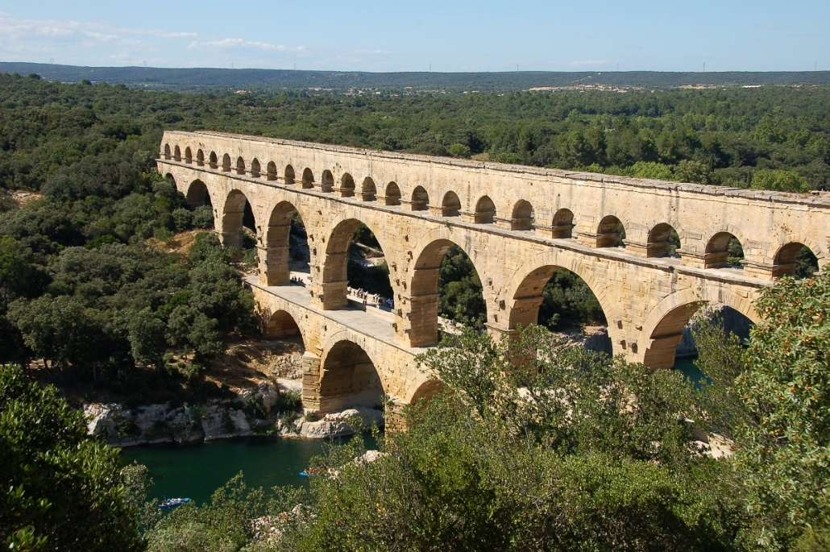

* Option 2: and called the Aqüeducte de les Ferreres, or Pont del Diable (Catalan) in Spain. It is one of the most famous *arcuationes* (latin name for this kind of bridge) in all of Spain and was built in Augustean times.[1] The architectural design is overall very uniform and the construction style is referred to as *opus quadratum*. That should make modelling easier.

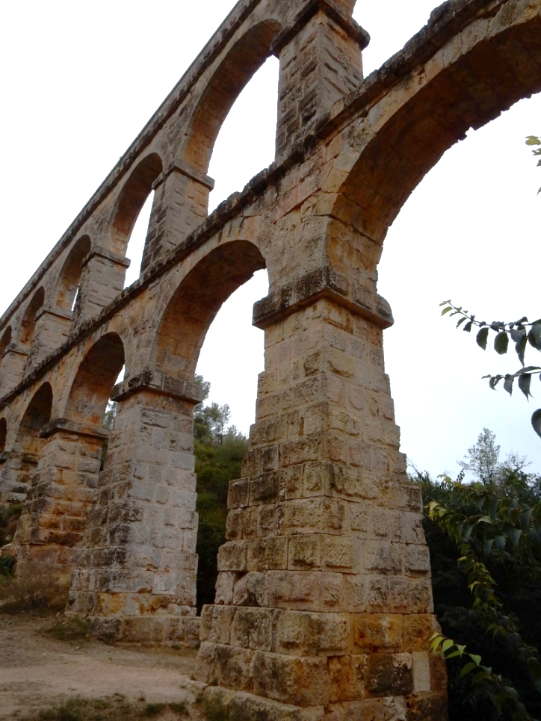

It crosses a dry valley, meaning the pillars are set on the ground and rectangular in shape, unlike river crossing bridges, that (sometimes) appear with wedge-shaped piers, like for example the Ponte Sant’ Angelo in Rome. Furthermore, the bridge has what I call a double gallery in the center and single gallery at maximum height besides it.

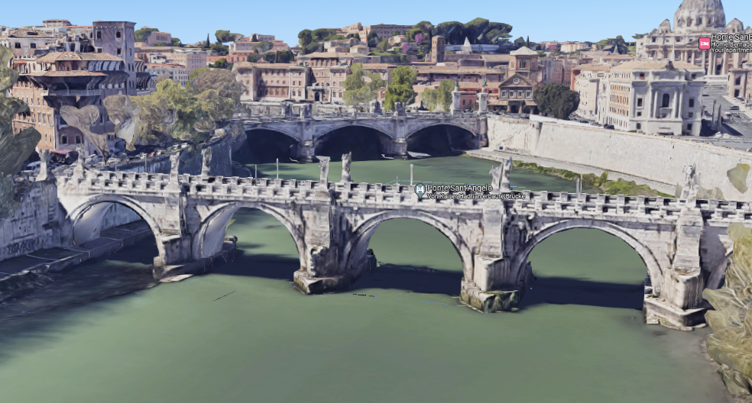[2]

Step 2. Distortion and scaling of the reference material

There aren’t many elevation or section plans published for this aqueduct bridge and after my initial research, it seems there currently exists no really accurate stone-true plan.

Instead, the archaeological literature did what it usually does: It copies, scales and reprints old plans (doing all that in the pre-digital era), resulting in some amount of distortion. In the referred publication it seems like the old French plan has some compression in the height axis (Z normally). In the referred publication[3] it seems like the old French plan (“alzado y planta”)[4] has some compression in the height axis, which could also be a product of me scanning the paper pages. It also fails to represent the steps in the pillar. This can be seen much better in the authors 2D plan (“detalles de la estructura en alzado y seccion vertical”), which respects the roman foot units and appears to be scaled more correctly.

Therefore, the old French depiction is from here on considered as fairly inaccurate and is only good for estimating the scale of the pillars besides the double gallery in the center. In the end, I scaled the spanish schematic based on pillar width and height of the lower gallery, and assumed, that ‘roundness’ and radius of the arches are more correctly reproduced here.

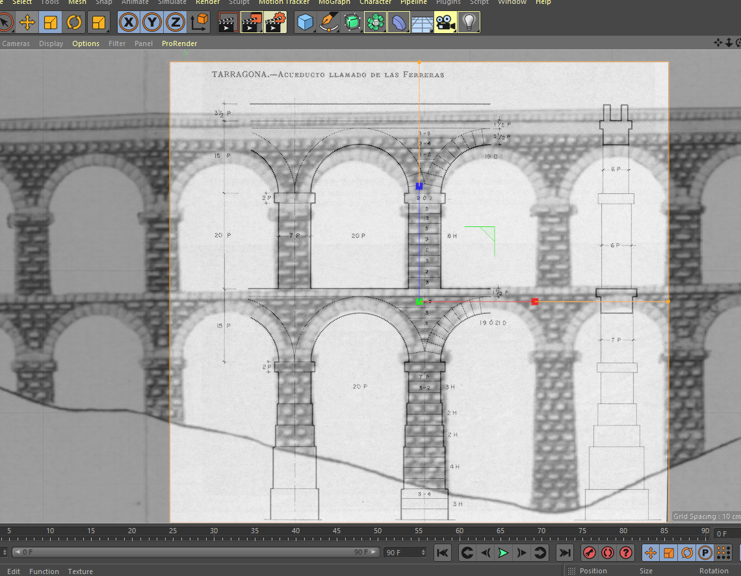

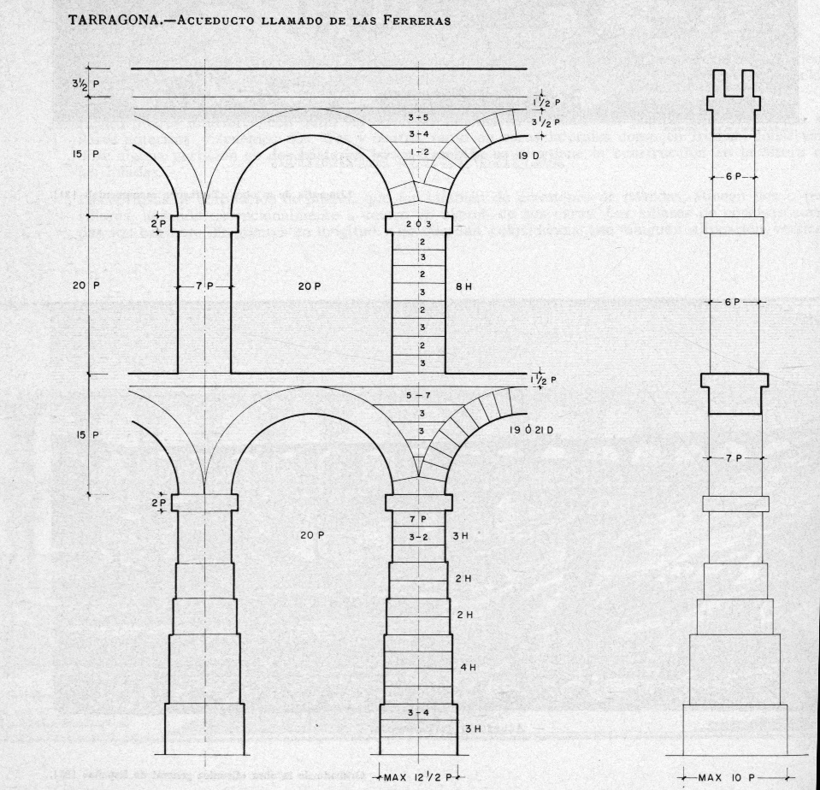

Step 3. The modelling approach and considerations on 3D Printing.

A choice that poses itself once the reference images are done, is whether to use box or spline modelling. IMO, the spline can create more complex shapes when modelling based on 2D images but just increases the handy work when dealing with simple geometries.

Thanks to the overall uniformity, symmetry and lack of serious architectural decorations (which is typical on a utility building outside of urban spaces), (which seems unsurprising on a utility building outside of urban spaces), box modelling seems to be the better approach, at least for the pillars. The surfaces of cubes can be easily extruded and stretched to match the existing plans, while providing more uniformity and simplicity than spline modelling could in the same amount of time.

With a few cubes a bottom pillar is quickly done. The layers seen in the background image represent the actual block height and indicates how many blocks were used per layer.

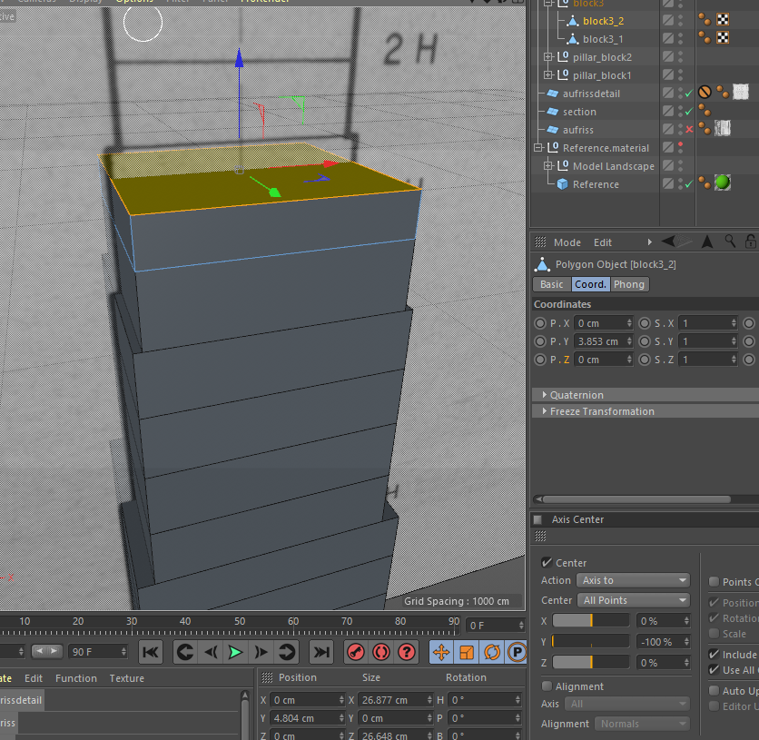

Noteworthy is the use of snapping to assure that the individual blocks are actually touching each other and not just floating close by.

or else: the 3D print may run into issues. For my experience I’d expect errors like layer shifts or bad layer adhesion, resulting in a failed print. This is very frustrating as such small oversights are hard to fix afterwards. Furthermore, the use of box modelling and the relative simplicity helps with avoiding mesh holes (in my experience), which confuse slicer programs and will create unusable gcode.

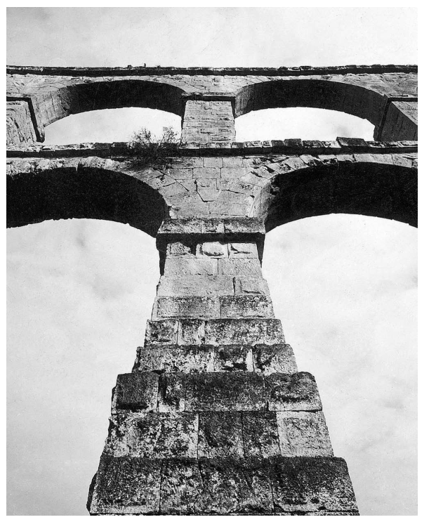One more question that arises from the use of such a standardized schematic plan is the possible lack of ‘realism’, or rather it misses certain details like architectonical decorations (ornaments, beveling, irregularities, etc.) that make it feel believable and alive. The resulting boxes may even look too simplistic. I would argue, that since the archaeological documentation does not reliably record any of that, e. g. in form of a LIDAR, or SFM generated point cloud, we could only hope to ‘fictionalize’ (aka fake) the missing details. One fix to this could be the recreation of the bossage visible on photos (see above). If I can come up with an efficient way to do this later on, I will report on that. However, what already can be said is that Bossage does not appear on every block and it’s generally debatable when it is a style element and when it is simply a sign of unfinished work. The arches (photo) appear with their bossage removed. It will need extra consideration and explanation why and where bossage was recreated, when it isn’t even well documented. In the photo below, we can even see various stages of how much of the bossage was removed.

Casado 2008, p. 15

From the perspective of 3D printing, it depends on the print scale and the purpose of the model. If I create bossage and the model will be printed at a small scale, they may not even appear because they disappear between layer heights. I would assume the model only serves to visualize the main components of an aqueduct bridge.

Step 4 Modelling the Center Gallery

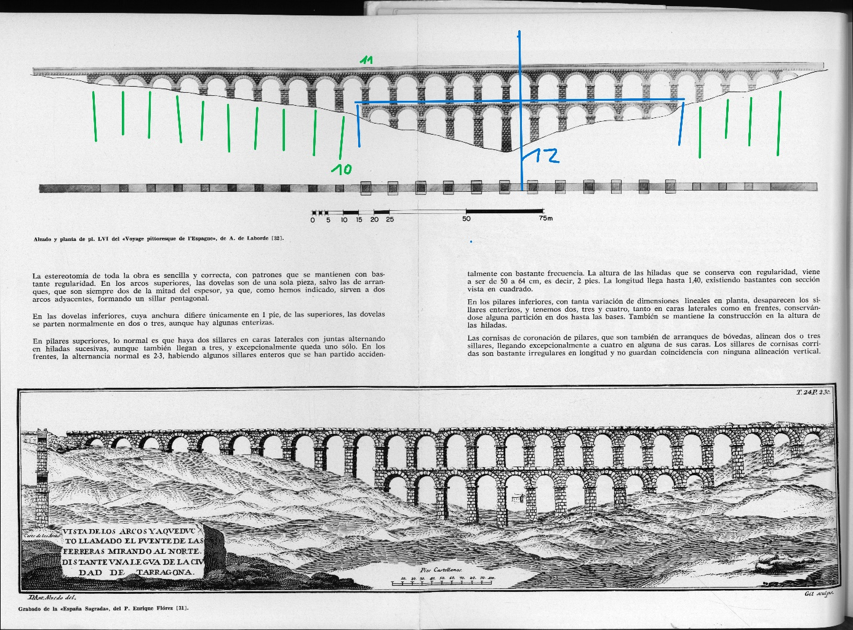

I call the blue part center gallery and the lower part is the bottom gallery. The pillar created in the last step was adjusted in width.

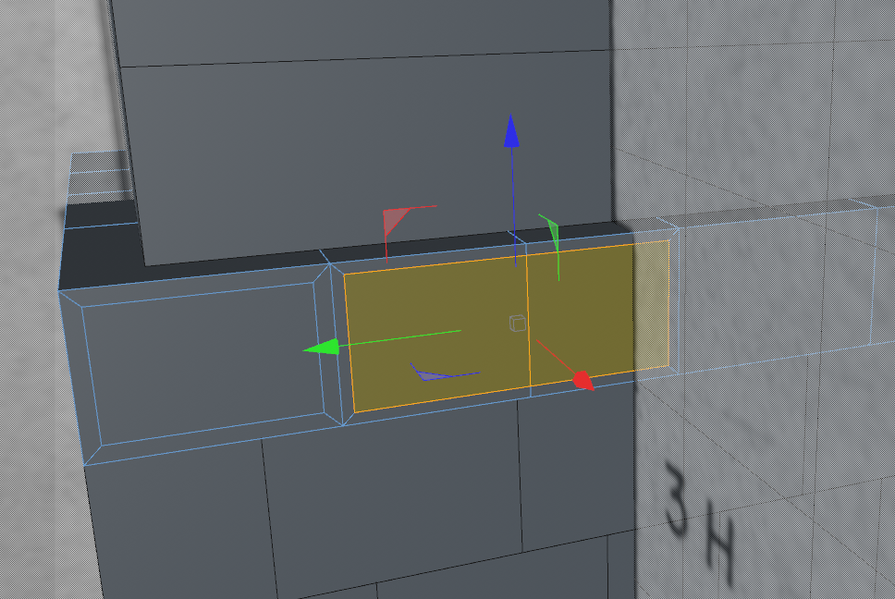Thanks to that an the remarks in the text, I understand the alternation of the ashlar layers. If one layer, seen frontally has only two blocks, the next one above will have three. Same on the sides. This prevents continuous vertical gaps. On the photos we can easily see, that albeit the layer height is uniform, the block width is pretty random. So I just used the tool ‘plane cut’ to slice the surface polygons of the boxes randomly, by hand. This menu can be be opened by a right clicke. There I also found the function ‘inner extrude’. This slices surfaces inside and creates a look similar to a painting frame, or inversely, a bossage. With multiple surfaces selected simultaneously, this was very efficiently done (screenshot below). The dimensions were pure guesses but still look quite convincing. I varied the offset of the bossage top surface from cube to cube so they don’t look too similar, just like in real life.

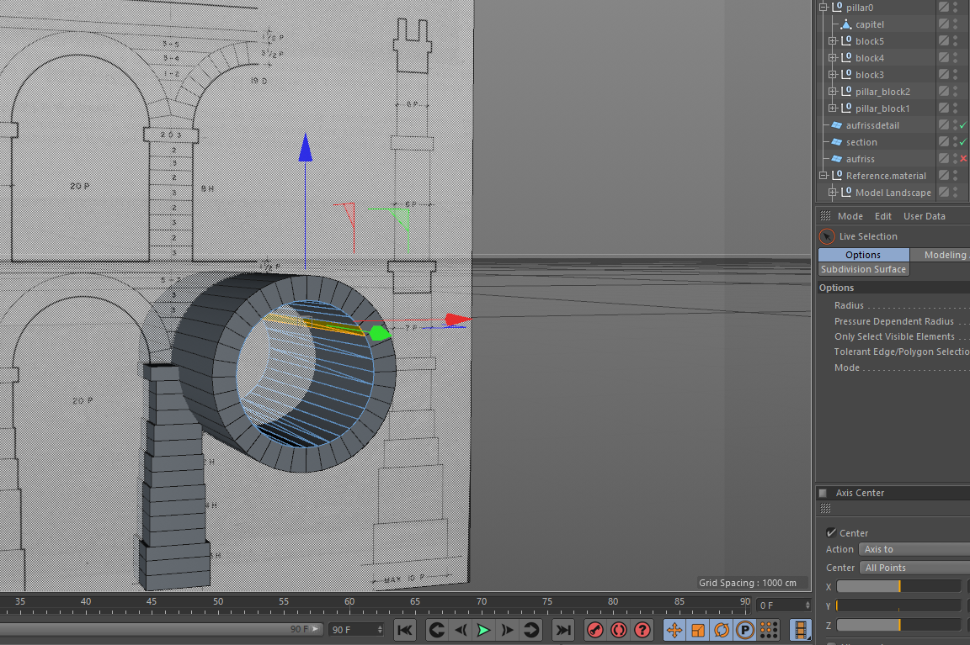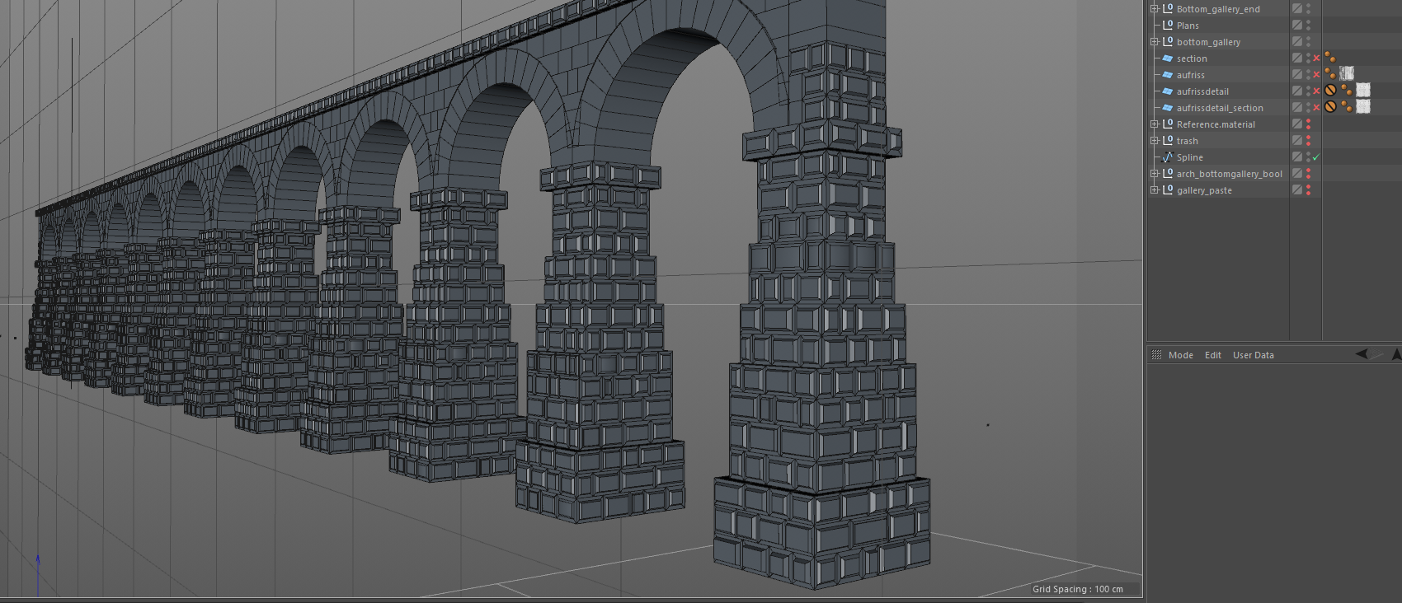

For the arches I decided to create two cyclinders with the correct number of segments (40 for the whole circle, 10 for each quarter) and an estimated radius by laying it over the plan (or at least I thought that was the correct number.)

With a Bool object, the inner cylinder subtracted from the outer cylinder and created a tube. This tube only needed to be cut and the surfaces adjusted to better meet the blocks as they appear on the plans and in photos. At this point I should have paid more attention to the available literature, because that number is not correct, at least of the top gallery.

Step 5 Center-Top-Gallery

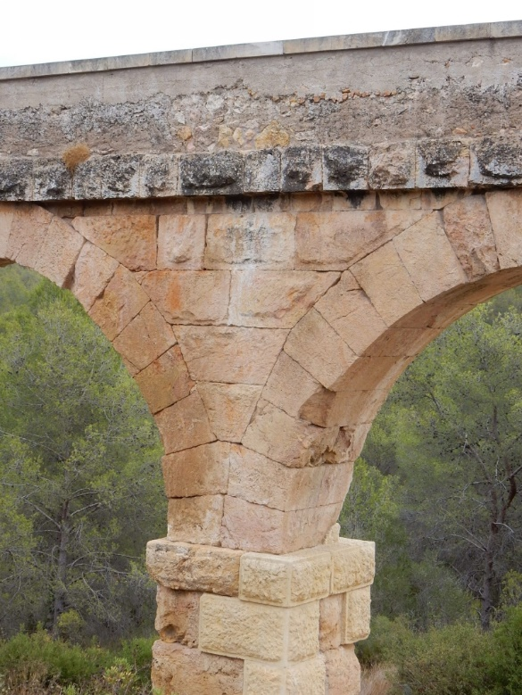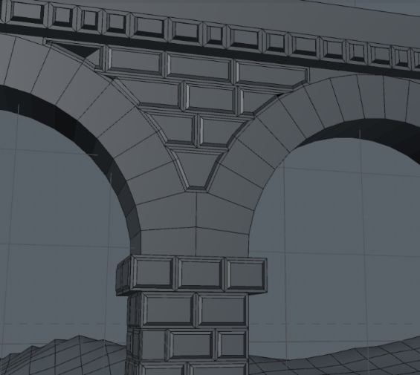The Center-Top-Gallery was done in very much the same fashion, except I paid more attention to the filler material in between archer and extruded surfaces more carefully, so that the follow the shape of the arches exactly. Noteworthy is how the two second arch blocks are larger and meet in the center. No plans accurately reproduced this, so I guessed based on photos (Casado 2008, p. 31 also notes this).

Step 6 Side-Galleries

The arches here are simple continuation of the same arches found in the top gallery and didn’t need to be modelled again. Or rather, this was my assumption because the publication did not include separate plans (As I found out later, it is actually mentioned in the text: Casado 2008, p. 31. More on that below).

Counting the number of stones on the pixelated photos gave further reason to accept this assumption. For the long pillar I could find neither accurate plans nor good photos, so I simply reused bottom and top pillars and filled the missing section with more cubes form the top pillar. This way, a plausible uniformity is maintained. The available photos show the side-gallery pillars to be in the soil, already at the level of the capstone of the bottom gallery

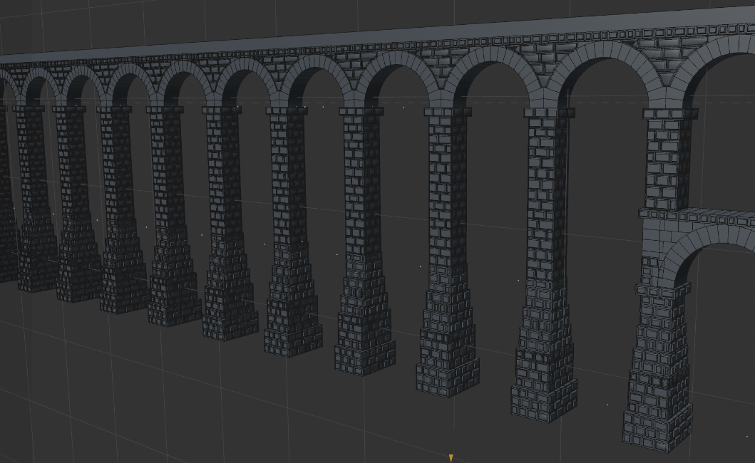

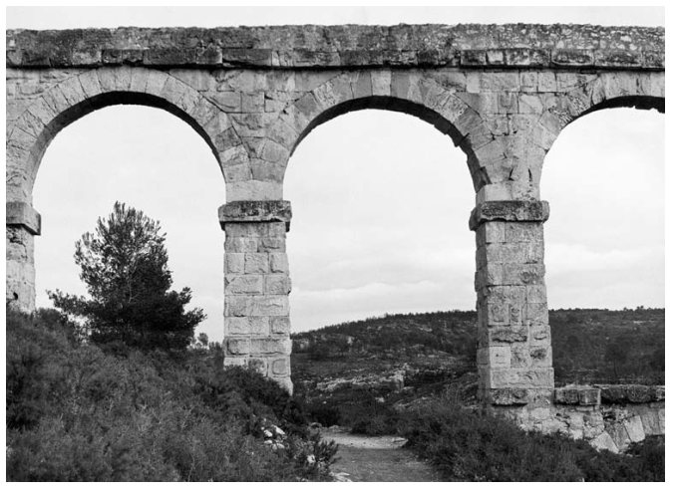

Step 7 Cutting the Model, Positioning in the Terrain, project platform

Originally, I modelled the entire length of the bridge. Soon I realized though, it wouldn’t fit entirely into the given reference terrain model because of its length. So, I had to cut some arches off. Also, I felt like the double gallery should be over the lowest part of the valley, as it is in real life. To cut the model I simply created vertical planes on the sides off the reference model, then closed the holes.

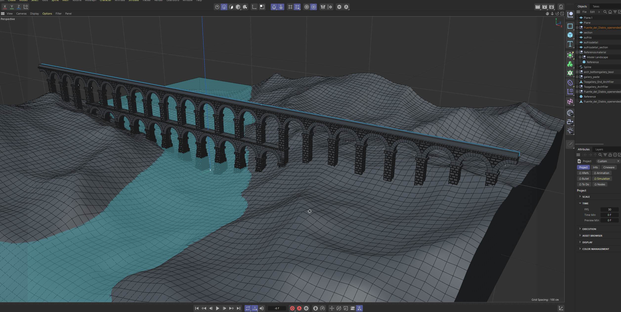

Besides the modelling, I decided to use github as the platform where I shre my files and and documentation and created a project. For the required blog posts I want to use the wiki section, which is only available if the project is public. But I am not sure if I am actually allowed to share the reference terrain and module.assement pdf. Probably ill cut them out.

Step 8 Textures and Renders

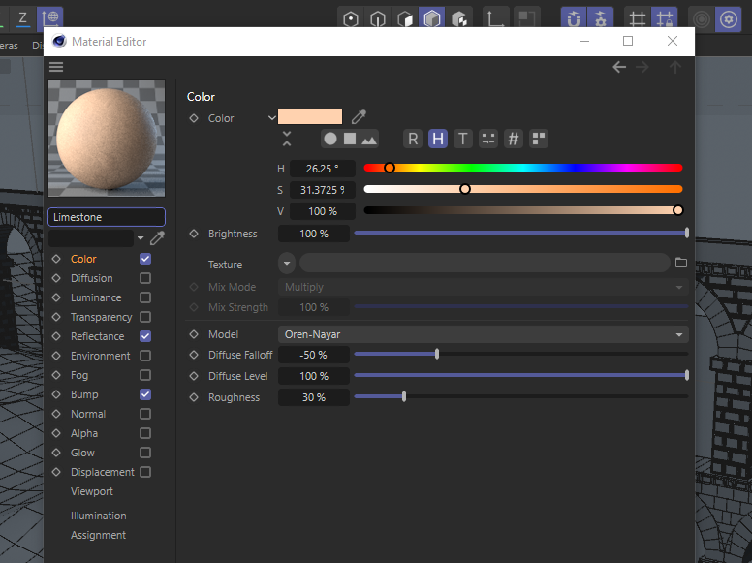At this point of the module exam I was very much out of time, so, a quick and efficient solution was needed for the textures. I could not find in the literature the exact building material, but I believe it to be limestone. It is a very porous stone and appears on photos with a sandy to orange or ochre color tone. I used the only limestone material Cinema4d had to offer and changed the color a bit towards orange.

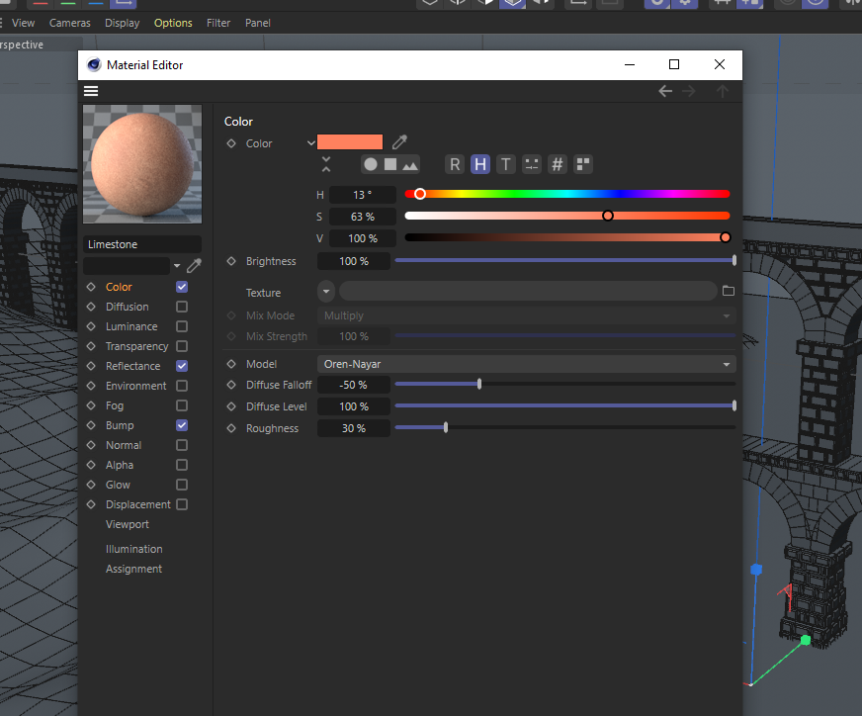

Finally I added a ‘physical sky’ and let the program make some renders, with the settings from the tutorials.

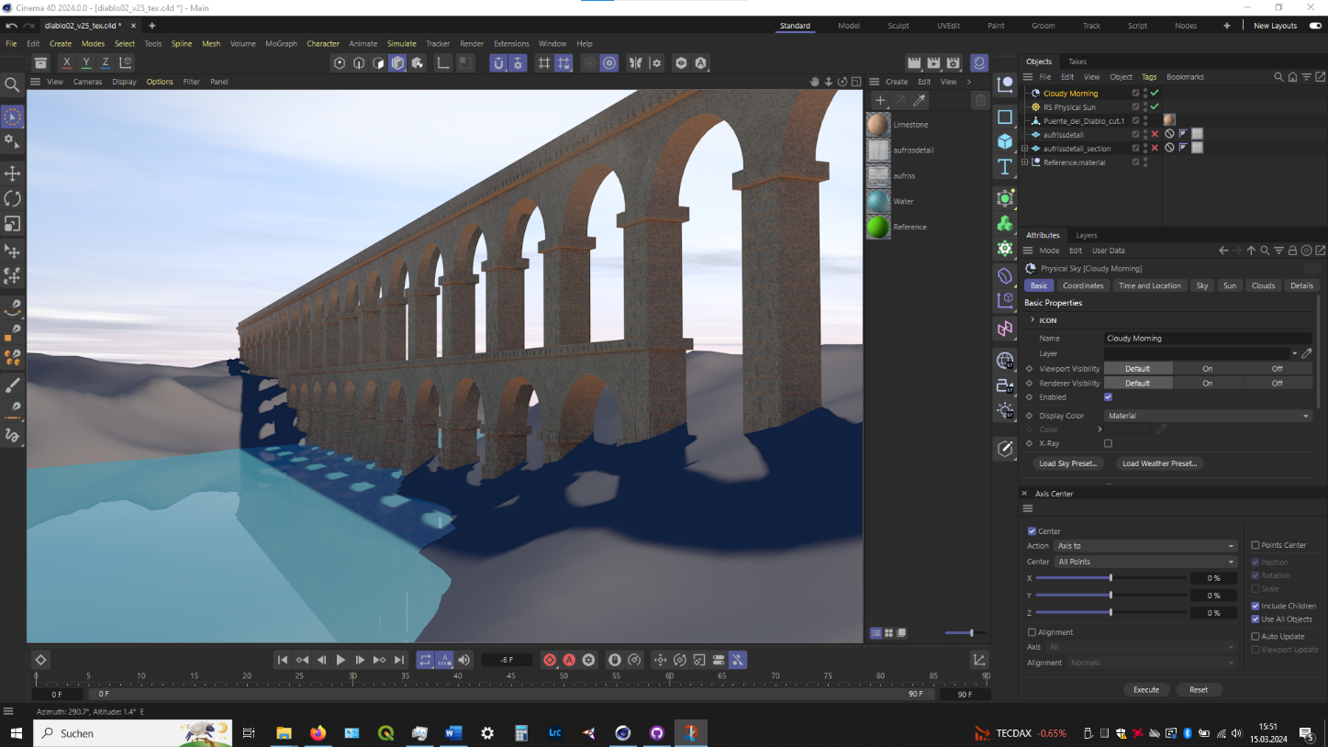

Step 9 Upload on github

I actually used github desktop to keep my files online and updated by frequently “pushing” all files. So now the only thing left tot do is to upload all the blogposts to the wiki and remove unnecessary files from the “filedump” folder.

1. E. Lopez 2016, p. 164-166
2. https://www.google.de/maps/

   @41.9022446,12.467981,33a,35y,246.19h,79.31t/data=!3m1!1e3?hl=de&entry=ttu
3. Casado 2008, p. 29-52
4. Casado 2008, p. 34